Software Design Document
Credit card fraud detection

Submitted by:
SABA MAJEED
Submitted to:
Dr. Musarrat Karim
Department of information technology
Faculty of computing
The Islamia university of Bahawalpur
Summary
This Software Design Document (SDD) provides a complete and detailed design of the Credit Card Fraud Detection system. The document is derived from the approved Software Requirement Specification (SRS) and follows the provided SDD template. It explains the system architecture, internal components, data flow, data models, algorithms, external libraries, UML diagrams, and user interaction concepts.
The system is designed to automatically detect and classify fraudulent credit card transactions using a hybrid machine learning approach (gradient boosting/forest models with optional deep learning) and business rules. The goal is to enable real-time fraud screening with high accuracy, low latency, and clear explainability for analysts and customers.
1. Application architecture
1.1 Architectural style
The system follows a Modular Pipeline-Based Architecture tailored for streaming data and real-time decisioning. Each module is independent yet connected through well-defined data flow stages.
Layers:
- Input Layer: Transaction event ingestion (amount, merchant, device, geolocation, time).
- Preprocessing Layer: Data validation, normalization, feature enrichment (historical aggregates, velocity features).
- Model Layer: Fraud detection models (gradient boosting, deep learning), rule engine, and ensemble.
- Inference Layer: Real-time scoring, thresholding, and decisioning.
- Evaluation Layer: Performance metrics, drift monitoring, and feedback loop.
- Output layer: Decision ,alert, case creation, dashboard and audit logs.
- High architecture diagram:
- 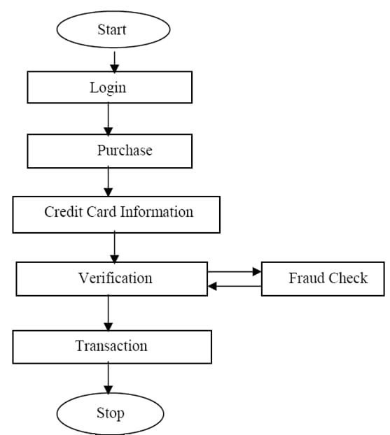
2. System components design
2.1 Data ingestion & preparation module
- Responsibilities:
  - Validation: Schema checks, missing values, outlier handling.
  - Normalization: Scaling amounts, encoding categorical fields.
  - Feature engineering: Velocity features, geolocation mismatch, device fingerprint risk, merchant risk, user behavior profiles.
  - Dataset splitting: Train/validation/test with temporal integrity.
• Inputs:
- Transaction events: Card ID, amount, currency, merchant, MCC, timestamp, device ID, IP, location.
- Reference data: Cardholder profiles, merchant risk lists, geolocation databases.
- Labels: Historical fraud outcomes (chargebacks, confirmed cases).
• Outputs:
- Structured datasets: Model-ready features for batch training.
- Feature store entries: Real-time aggregates and profiles.
• Key functions:
- validate event()
- transform features()
- build_ feature_ store()
- split _dataset()
2.2 Model training module
- Responsibilities:
  - Model selection: Gradient boosting (XG Boost/Light GBM), Random Forest, optional deep learning (Tab Net/MLP).
  - Training: Class imbalance handling (SMOTE, class weights), cross-validation, hyperparameter tuning.
  - Explainability: SHAP feature importance, rule attribution.
  - Persistence: Save trained artifacts and metadata.
- Key functions:
  - load dataset()
  - train model()
evaluate model()
  - save artifacts()
- Outputs:
  - Model weights: Serialized models.
  - Thresholds: Decision thresholds per segment.
  - Explainability assets: Feature importance, calibration curves.
2.3 Inference (fraud detection) module
- Responsibilities:
  - Model serving: Low-latency scoring API.
  - Rule engine: Deterministic checks (e.g., impossible travel, blocked device, merchant blacklist).
  - Ensemble decisioning: Combine ML score + rules + segment thresholds.

- •
Decision outcomes: Approve, decline, step-up verification, or flag for review.
• Supported signals:
- Behavioral anomalies: Unusual spend, time-of-day deviations.
- Velocity: Rapid transactions across merchants or geographies.
- Geolocation/device mismatch: New device in distant location shortly after local use.
- Merchant risk: High-risk MCC, known compromised merchants.
- Network patterns: Linked cards/devices/IPs with prior fraud.
• Key functions:
- score transaction()
- apply rules()
- make decision()
- log_outcome()
- 2.4 Evaluation & reporting module
- Responsibilities:
- Metrics: Precision, recall, F1-score, ROC-AUC, PR-AUC, false positive rate, detection latency.
- Monitoring: Data drift, concept drift, model stability, alert volumes.
- Visualization: Confusion matrix, lift charts, SHAP summaries.
- Feedback loop: Analyst labels and customer confirmations to update training data.
- Key functions:
- compute metrics()
- generate reports()
- monitor drift()
- close feedback loop
3 UML Diagram
3.1 Use case diagram
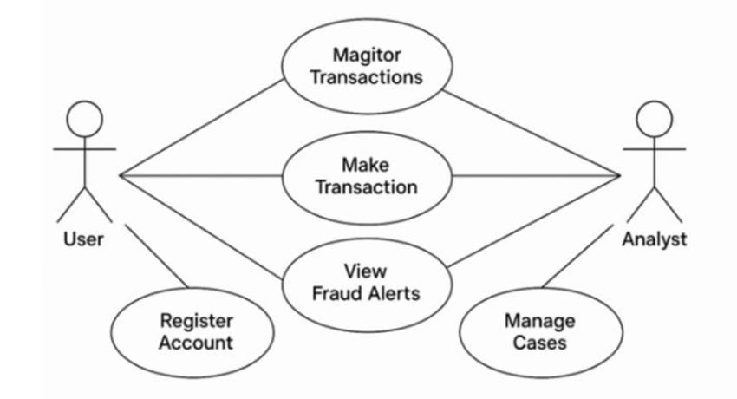
Sequence diagram:
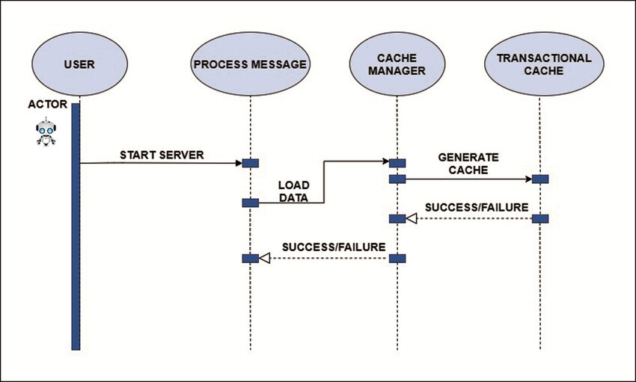
4 Data model schema
4.1 Conceptual data model
Entities:
- Transaction
  - Transaction ID
  - Card ID
  - Amount
- Device ID
- IP Address
- Geolocation
Feature
- Feature ID
- Transaction ID
- Feature Vector
Rule
- Rule ID
- Name
- Condition
Cas
- Case ID
- Transaction ID
- Status
- Assigned To
ER Diagram:
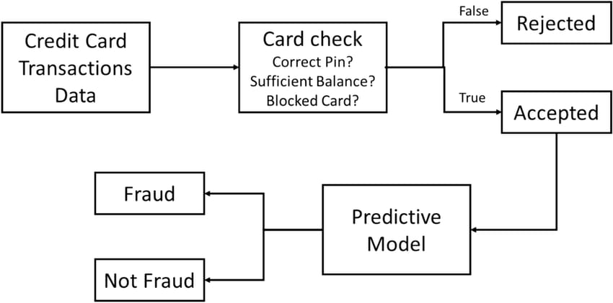
5. User interface design
5.1 Design philosophy
- Simplicity: Clear, minimal, and responsive UI for analysts and operations teams.
- Explainability: Prominent display of fraud score, decision, and top contributing factors.
- Accessibility: High contrast, keyboard navigation, and readable charts.
5.2 Screens description
- Transaction Review Screen
  - Features: Transaction details, fraud score, decision, SHAP explanation, rule hits.
  - Actions: Approve/decline, escalate, add notes, assign case.
- Alert & Notification Screen
  - Features: Customer alert status, verification prompts (OTP/step-up), communication log.
  - Actions: Resend alert, mark verified, update contact method.
- 6. External libraries & APIs
Library/Service | Purpose
Scikit-learn / XG Boost / Light | GBM Machine learning models and training
Py Torch (optional) | Deep learning for tabular/sequence models
Pandas / NumPy | Data handling and numerical operations
Kafka / Pulsar | Streaming ingestion and event processing
Redis / Feature Store (Feast) | Real-time feature retrieval
Fast API / Flask | Model serving and REST APIs
7. Coding conventions & design constraints
Coding conventions
- Standards: Python PEP-8.
- Structure: Modular, function-based and service-oriented design.
- Naming: Meaningful variable, function, and class names.
- Documentation: Docstrings and inline comments; API contracts with Open API.
- Testing: Unit, integration, and performance tests; reproducible pipelines.
Design constraints
- Latency: End-to-end decision within 300 MS for real-time transactions.
- Scalability: Horizontal scaling to handle peak loads (e.g., holiday spikes).
- Security & Compliance: PCI DSS, TLS encryption, RBAC, audit logging.
Notes on implementation
- Model strategy: Start with gradient boosting for strong tabular performance and interpretability; add deep learning for sequential/temporal patterns if justified.
- Ensemble logic: Weighted combination of ML score and rule severity; segment-specific thresholds (e.g., new device vs. known device).
- Feedback loop: Analyst labels and customer confirmations feed back into training data; periodic retraining with drift checks.
- Explainability: SHAP values and rule hits surfaced in UI for trust and auditability.

